Flight Delays and Cancellations

# What are the states most in the canceled flights by weather on Saturday?

**Link(s):**

[https://public.tableau.com/app/profile/rawan.alsaedi/viz/FlightDelaysa](https://public.tableau.com/app/profile/rawan.alsaedi/viz/FlightDelaysandCancellations_16693005577860/FlightCancellationsDashboard1?publish=yes) [ndCancellations_16693005577860/FlightCancellationsDashboard1?publ](https://public.tableau.com/app/profile/rawan.alsaedi/viz/FlightDelaysandCancellations_16693005577860/FlightCancellationsDashboard1?publish=yes) [ish=yes](https://public.tableau.com/app/profile/rawan.alsaedi/viz/FlightDelaysandCancellations_16693005577860/FlightCancellationsDashboard1?publish=yes)

**Summary:** The dashboard describes the two charts, where the map shows all the states in which the flights canceled occurred by weather reason on Saturday and the chart shows that Illinois (IL) state is the most canceled state for flights with 102 canceled flights and then Texas (TX) state comes next with 92 canceled flights.

**Design:** The reason for using the dashboard is the need to display more than one chart, where the map chart is used to display the geographic area for United States. This makes it easy for users to see the most canceled areas. Also, we used Pie chart to display the top states in the canceled flights. Also, we can observe that we can selected any specific day of the week by using the day of the week filter and also, we can select canceled reason by using cancellation reason filter. The colors have been carefully selection to make it easy to read by everyone, even those with color blindness.

**Resources:** <https://www.kaggle.com/datasets/usdot/flight-delays>

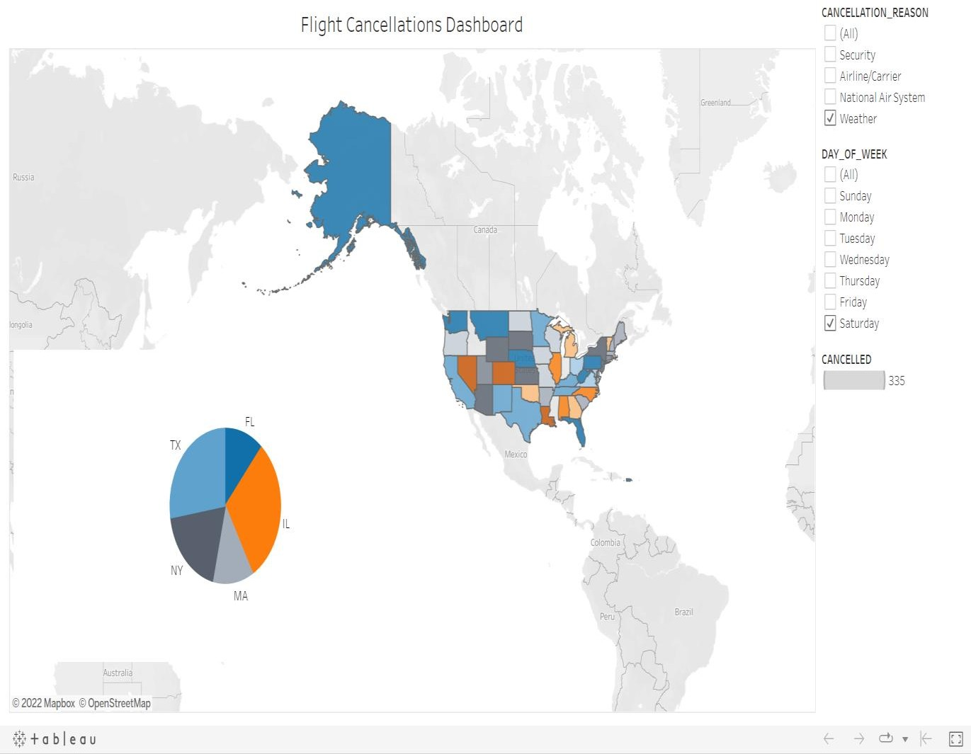



**Links:** [https://public.tableau.com/app/profile/rawan.alsaedi/viz/FlightDelaysandC](https://public.tableau.com/app/profile/rawan.alsaedi/viz/FlightDelaysandCancellations_16693005577860/CitiesFlightCancellations?publish=yes) [ancellations_16693005577860/CitiesFlightCancellations?publish=yes](https://public.tableau.com/app/profile/rawan.alsaedi/viz/FlightDelaysandCancellations_16693005577860/CitiesFlightCancellations?publish=yes)

**Summary:** The heat map describes the number of flight cancellations for each city on the fifth day of the month, it becomes clear to us that Chicago is the most city cancelled their flights with 420 cancelled and then Dallas Fort Worth with 283 and next comes New York with 247 cancelled flights.

**Design:** The heat map is used that provides a visualization of the data with color to make it easier for user to see the most canceled flights cities. we can select any specific day of the month by using the day filter. The colors have been carefully selection to make it easy to read by everyone, even those with color blindness.

**Resources:** <https://www.kaggle.com/datasets/usdot/flight-delays>

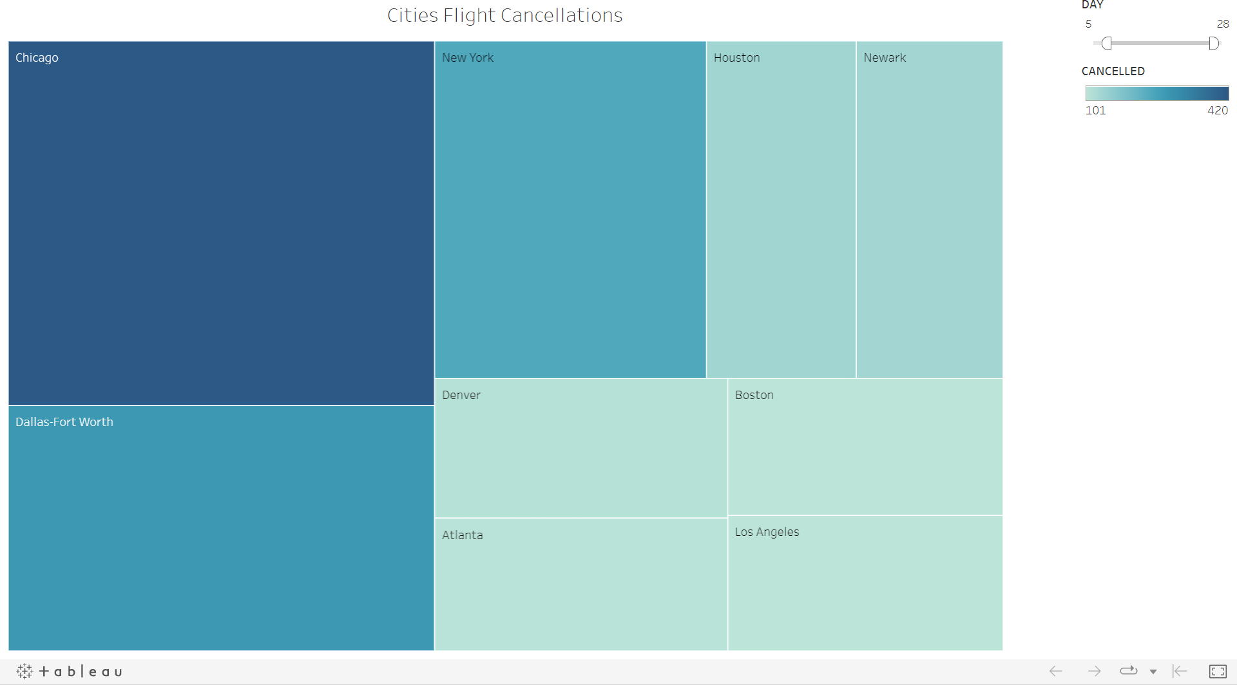

# What are the most airline flight delays in August?

**Links:** [https://public.tableau.com/app/profile/rawan.alsaedi/viz/FlightDelaysa](https://public.tableau.com/app/profile/rawan.alsaedi/viz/FlightDelaysandCancellations_16693005577860/AirlineFlightDelays?publish=yes) [ndCancellations_16693005577860/AirlineFlightDelays?publish=yes](https://public.tableau.com/app/profile/rawan.alsaedi/viz/FlightDelaysandCancellations_16693005577860/AirlineFlightDelays?publish=yes)

**Summary:** The bar chart used to display the number of flight delays per Airline in the August, and the chart shows that Southwest Airlines Co is the most Airline delays their flights. There were above 17k flight delays. And then the American Airlines Inc with about 16k and the lowest one is Virgin America with 637.

**Design:** A bar chart is used to show data in the easier understand and clear way. we can select any specific month by using Month filter. The colors have been carefully selected to make it easy to read by everyone, even those with color blindness.

**Resources:** <https://www.kaggle.com/datasets/usdot/flight-delays>

